EXPT NO: 3 | Designing Multivariate Patterns
DATE: 12.01.2026 | Designing Multivariate Patterns

PRE-LAB QUESTIONS (PROVIDE BRIEF ANSWERS TO THE FOLLOWING QUESTIONS)
- Why is multivariate analysis essential in real-world AI problems?
Multivariate analysis helps AI systems understand relationships among multiple variables simultaneously, which reflects real-world complexity and improves prediction accuracy.
- What challenges arise when visualizing high-dimensional data?
High-dimensional data is difficult to represent visually due to clutter, overlap, and human cognitive limitations in interpreting many variables at once.
- How does correlation analysis support feature selection?
Correlation analysis identifies redundant or highly related features, helping select the most informative variables and reduce model complexity.
- What are ethical concerns in healthcare data visualization?
Privacy, data anonymization, misinterpretation of patterns, and bias amplification are key ethical concerns in healthcare visualization.
- Give examples of multivariate data in AI systems.
Patient health records, customer behavior analytics, sensor data in autonomous vehicles, and financial risk assessment datasets.
IN-LAB EXERCISE:
OBJECTIVE:
To discover relationships among multiple variables using multivariate visualization.
SCENARIO:
A hospital analytics team studies patient health records to identify relationships between age, BMI, glucose levels, and blood pressure for early disease prediction.
IN-LAB TASKS (Using R Language)
- Generate scatter plot matrix
- Apply color encoding for age groups
- Identify correlated health indicators

CODE:
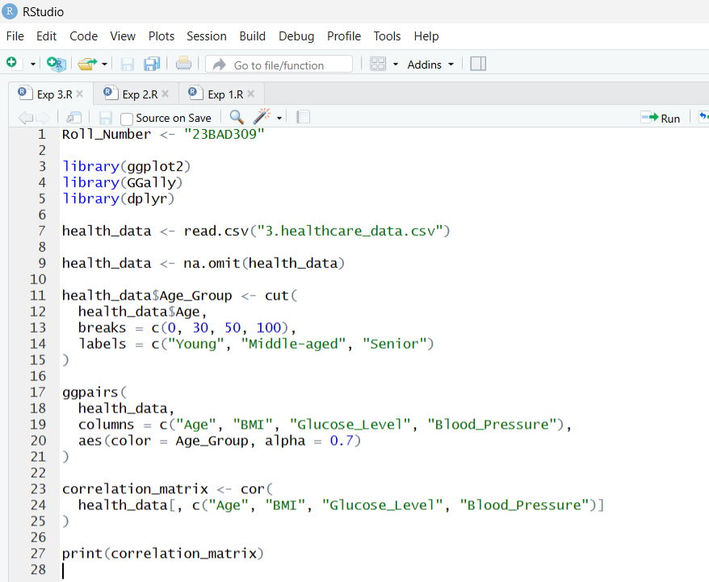

OUTPUT:
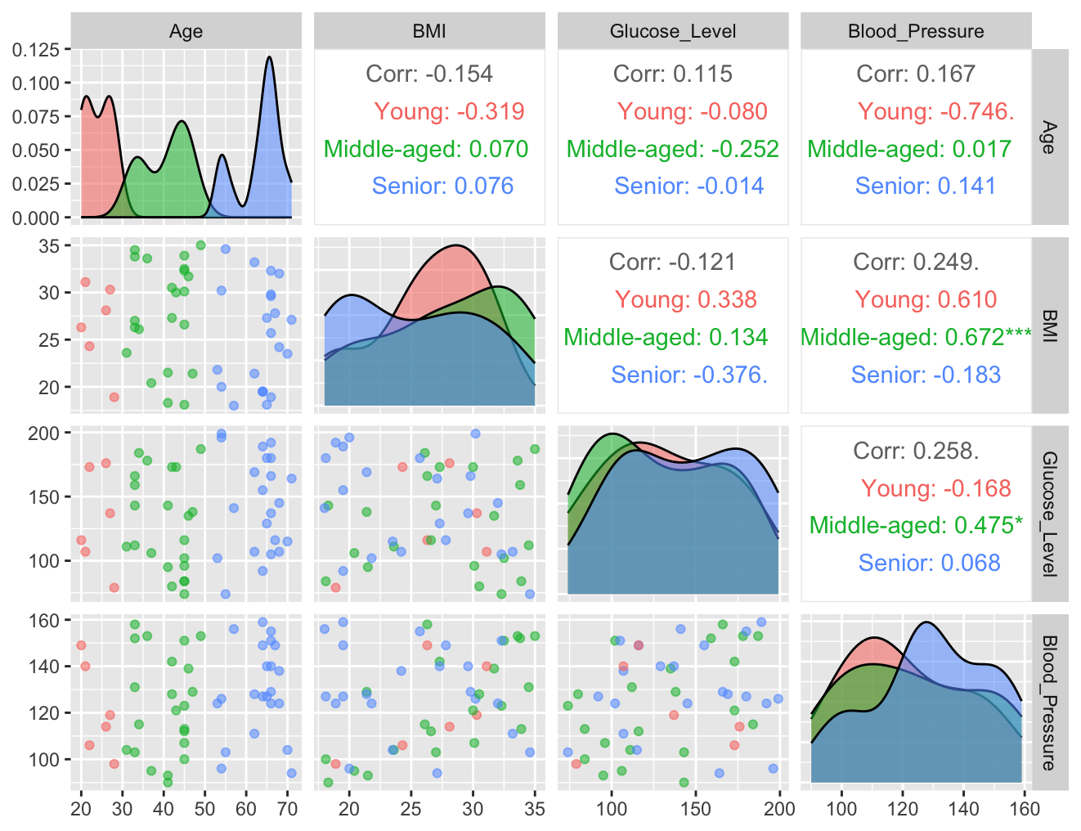
POST-LAB QUESTIONS (PROVIDE BRIEF ANSWERS TO THE FOLLOWING QUESTIONS)
- Which health parameters show strong correlation?
BMI and Blood Pressure, as well as Glucose and Age, show relatively strong correlations.
- Why correlation does not imply causation in medical data?
Correlation only indicates association, not direct cause, as medical outcomes are influenced by multiple confounding factors.

- How can these patterns assist predictive healthcare AI?
They help identify risk factors, improve feature selection, and enable early disease prediction models.

- What visualization limitations exist for high-dimensional data?
Overplotting, visual clutter, and reduced interpretability make high-dimensional visualization challenging.

- How can dimensionality reduction improve visualization?
Techniques like PCA reduce variables into fewer components, preserving patterns while improving interpretability.

ASSESSMENT
Description | Max Marks | Marks Awarded
Pre Lab Exercise | 5
In Lab Exercise | 10
Post Lab Exercise | 5
Viva | 10
Total | 30
Faculty Signature

